**Smart Parking Systems for Smart Cities**

# Introduction :

## *Overview:*

In the recent years as cities are growing, cars on the road are increasing therefore we need to improve parking facilities to reduce traffic jams on the roads.

## *Purpose:*

By this project one can able find the available parking slots for their car without wasting time.

Literature Survey :

## *Existing problem:*

We keep driving to find empty slots in parking.Thereby increasing our fuel consumption.

.

## *Proposed solution:*

By using IOT solution we will be able to find parking slots in Parking space instantly.We will get real time updates on how many cars have entered and exited.

## *Hardware:*

We are using NodeMCU,IR sensors and ultrasonic sensors.

## *Software:*

IBM cloud,Node-Red services.

# Theoretical Analysis:

Block Diagram:

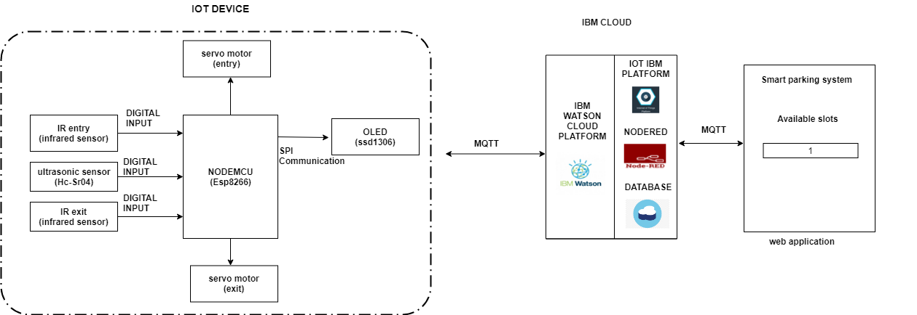

## *Advantages:*

* It is highly feasible for extremely small sites that are unable to accommodate a conventional ramped parking structure
* There is a minimal staff requirement if it is used by known parkers
* Emissions are greatly brought down and reduced.

## *Disadvantages:*

* It requires a maintenance contract with the supplier.
* It may be a bit confusing for unfamiliar users.

# Conclusion :

Thus, the proposed system can gather the entry and exit status of the cars and give the available status of parking slots.

# Future Scope :

We can create a network of different parking structures,find out the nearest parking slot available in the nearest parking structure using GPS.

PROJECT PLANNING

**PROJECT KICKOFF**

Project Manager: Ankit Ajay Singh

Project Name: Smart Parking System for Smart Cities

Project ID: SPS_PRO_251

**Project Summary:**

This project is intended to create a smart parking system for smart cities.This project uses

**Project Requirements:**

Python,IBM Cloud,IBM Waston

**Functional Requirements:**

IBM Cloud

**Technical Requirements:**

Python,IOT

**Software Requirements:**

Waston IOT,Node Red,Python IDLE,

**Project Deliverables:**

Our project involves json and IOT technology. It will save time and fuel.

Cloud Establishment

1. Creating a IoT device using IBM IoT platform

2. Connection Establishment between IoT Sensor Simulator and IoT device

3. Graphical Visualisation of the data recieved in IBM Cloud

Node Red Configuration

4. Connection establishment between NodeRed and IBM IoT platform

5. Data representation in UI ( Entered,Exited,Available Slots)

**Project Team:**

(AS)

Ankit Singh

**Project Schedule:**

1.Project Planning & Kickoff (1 Days)

* Project Scope, Schedule, Team & Deliverables(1 Days)

2.Setup Environment (1 Days)

* Create IBM Cloud Account(0.1 Hrs)
* Create Node-Red Application(0.5 Hrs)
* Create an IBM Watson IoT Platform.(0.2 Hrs)
* Install Python IDE(1 Hr)

3.Setup Hardware And Develop The Code(1 Day)

* Connect The IOT Simulator To Watson IOT Platform (0.5 Hrs)
* Publishing data using MQTT communication.(0.5 Hrs)

4.Configure The Nodered To Get The Data From IBM IOT Platform And (1 Day)

* Install The Required Nodes In Your Nodered.(1 Hrs)
* Connect To Your IBM IOT Device to get the Data.(2 Hrs)
* Configure Your Nodered To Get Data Using Http Requests.(1 Hrs)

5.Building A Web App

* Configure the Nodes To Display entry and exit status of the cars which we get from IBM IOT Platform In UI(3 Hrs)
* Configure The Nodes For Creating Buttons And Sending Commands To IOT Platform.(1 Hrs)

6.Configure Your Device To Receive The Data From The Web Application.(1 Day)

* a.Write A Python Code To Subscribe To IBM IOT Platform And Get The Commands(2 Hrs)